|  |
| --- |
| Vision Soil Analyzer |
| **Current status and results** |
|  |

|  |  |  |  |  |
| --- | --- | --- | --- | --- |
| Date  15 June 2015 | Reference  xxxxxxxxx | Version  Rev. A | Status  Concept / Final | Name Author  Jelle Spijker |

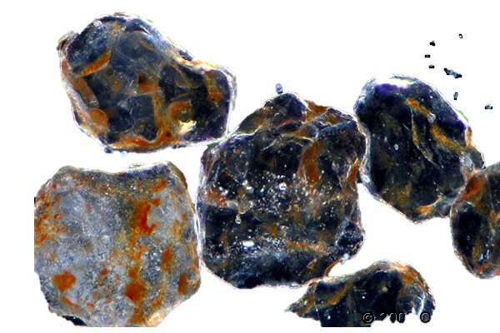

Vision Soil Analyzer

**Contact gegevens:**Jelle Spijker (495653) – 06-43272644 – [j.spijker@ihcmerwede.com](mailto:j.spijker@ihcmerwede.com)

**Disclaimer HAN:**

Door ondertekening van dit voorblad, bevestigen wij dat het – door ons ingeleverd(e) werkstuk/rapport/scriptie (verder te noemen “product”) – zelfstandig en zonder enige externe hulp door ons is vervaardigd en dat wij op de hoogte zijn van de regels omtrent onregelmatigheden/fraude zoals die vermeld staan in het opleidingsstatuut.

In delen van het product, die letterlijk of bijna letterlijk zijn geciteerd uit externe bronnen (zoals internet, boeken, vakbladen enz.) is dit door ons via een verwijzing conform APA-norm (b.v. voetnoot) expliciet kenbaar gemaakt in het geciteerde tekstdeel (cursief gedrukt).

**Copyright Royal IHC:**

This document remains the property of “IHC Holland B.V.” All rights reserved. This document or any part thereof may not be made public or disclosed, copied or otherwise reproduced or used in any form or by any means, without prior permission in writing from “IHC Holland B.V.”

This project finds its roots in the minor Embedded Vision Design taught at the university of applied sciences HAN. During this minor a portable embedded device is being developed which analyses soil samples using a microscope. This Vision Soil Analyzer hereafter referred to as VSA, analyzes soil samples using the optical properties. It’s main function is: **Presenting quantifiable information to a user on the properties of soil: such as color, texture and structure.**

Current methods, like the Particle Size Analysis using a sieve and hydrometer are time consuming and non-portable. To facilitate quick, accurate and on location soil research an embedded device has been developed. This VSA analyzes soil samples using a microscope and gives the user acceptable and quick results on the soil visual properties.

Quick and reliable results are a welcome addition into any laboratory, this combined with a device that is light and portable gives its users an added benefit of shortened logistical operations for their soil samples. This results in some serious time benefits.

## Goal

The goal is to develop a device which analyzes soil samples using a digital microscopic camera connected to a microcontroller. The properties that are deemed possible to analyze using this technique are, color, texture and structure. The goal is to perform the calculation within a time span of a five minutes. The results are presented to the user using a generic HDMI monitor or can be download from the device in PDF format. These results fall in to a predefined and for a user acceptable error margin.

## Presented information

The user gets information presented in the following formats:

|  |  |
| --- | --- |
| **Color** | * CIE La*b* color model presented as scatterplot with the mean values of each individual particle set out against the chromatic a* and b* axis. Studies indicate a correlation between organic carbon and the values in CIE La*b* color model * Redness Index is presented as statistical data for each individual particle, such as mean, min, max, range, standard deviation etc. Welch tests anova can be executed in order to determine which particle deviates from the rest. |
| **Texture** | * Particle Size Distribution Presented as a cumulative function. These properties show a correlation on water infiltration, pH buffering, buffering of organic materials and much more. |
| **Structure** | * Shape classification regarding each individual particle presented as histogram. The roundness and the angularity are determined and presented as sixteen individual classes. Ranging from high sphericity / well rounded to low sphericity / very angular. These properties show a correlation between erosion, biochemical and physical properties including tool degradation. |

# First test results

The test setup was a X64 desktop computer running Matlab 2014a. The microscope was placed in an open environment. This setup served as a testing ground for the various algorithms. The goal was to develop a test setup with which to test the various computer algorithms and validate the theory.

|  |  |
| --- | --- |
| **Success** | **Challenges** |
| Segmentation and identification of individual particle is possible for non-transparent particles | Segmentation of transparent particles is a challenge. This is critical to overcome, since systematic exclusion of a certain subset of particles gives inaccurate statistical results |
| Color model transformation can be strategically performed. Saving calculation time | Variations in color related results. Due to changing light conditions during the day. Test result relating to color could not be reproduced during the day. |
| Volume of the particles, could be roughly calculated, from a 2D image | Overlap of smaller particles by bigger particles. The combination of the two samples overlapping particles where registered as one bigger particle. This gives distorted PSD results. |
| Individual particles where identified, and the Fourier Descriptors could be calculated. The inverse of these descriptors translated to accurate results. See figure 1 | No correlation between estimated shape classification and human shape classification.  The Neural Network was fed an in perfect an small learning dataset. |
|  | Calculation of image consisting of 5e6 pixels takes roughly 7 minutes |



Figure Fourier Descriptors of a soil particle

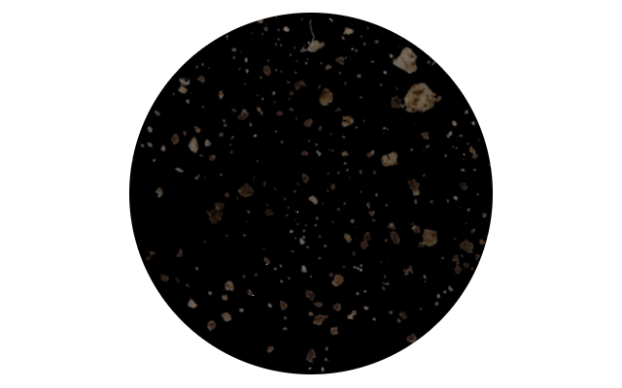

Figure Soil particles separated from the background

# Second (current) stage

The second stage of this project consist of a transfer from Matlab to C++ running on an embedded Linux ARMv7 device. This consist of rewriting and designing all the algorithms from scratch. Implementing and unit testing them. Design and construction of a light condition case. Design and construction of a PCB for control of the light condition case and user interaction. See figure 3 and 4.

The source code currently consists of 7000+ lines. Although the code can be run from a Linux Desktop computer and can probably be ported to a Windows computer. The code and algorithms are designed and optimized for the ARM architecture.

|  |  |
| --- | --- |
| **Success** | **Challenges** |
| Convincing MTI and IHC of the possibilities of this project. |  |
| **Program can be run from a Linux Desktop computer and an ARM microcontroller** |  |
| **Vision algorithms are performed with 0% error margin compared with their Matlab counterpart. Speed increase is 650% on average** | **Segmentation of transparent particles is a challenge. This is critical to overcome, since systematic exclusion of a certain subset of particles gives inaccurate statistical results** |
| Statistical calculations are performed within an error margin of 0.0001% compared with their Matlab counterparts. The speed increase is 400% | Since this class is used throughout the project and still takes up to 9% of the total time be called upon. Further optimization is advised. |
| Fast Fourier Transformation are performed within an error margin of 0.001% compared with their Matlab counterparts. The speed increase is 230%. | Further optimization is needed. The current C++ code is compiled with X64 desktop optimization. ARM machine code can perform this process with less instructions. Rewrite the FFT function in assembler for a big speed increase |
| The Neural Net can learning multiple Logical AND OR NAND setups. | Creation of an accurately classified soil particle database to learn the neural net. |
|  | Overlap of smaller particles by bigger particles. The combination of the two samples overlapping particles where registered as one bigger particle. This gives distorted PSD results |
|  | Scaling of pixels to SI unit mm |
| Light conditions case results in better reproducible color test results. Error margin of 10%. | Creation of a better sample environment |
| PCB electronics interfaces correctly with the ARM microcontroller |  |

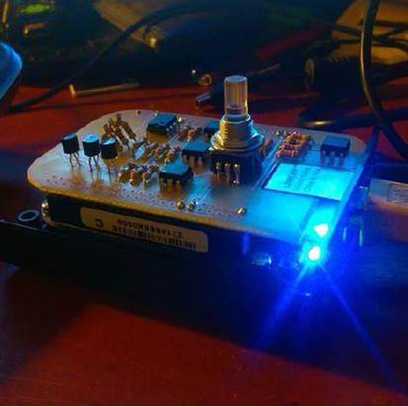

Figure Embedded Microcontroller

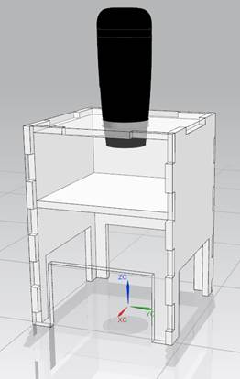

Figure Light Environment Casing with Microscope

# Release candidate

The goal of the future release candidate is to have a field ready device which is portable. The results are presented to the user using a generic HDMI monitor of can be download from the device in PDF format. These results fall in to a predefined and for a user acceptable error margin. The preliminary requirement below are an indication of possible requirements for a release candidate and are still subject to chance.

Functional:

* Calculations are done in a time span of five minutes.
* Calculation are within an acceptable and predefined error margin
* Results of the Particle Size Distibution are conforming NEN and ISO norms, such as but limited to NEN-ISO 9276-1 till 6.
* The device weighs less than 10 kg.
* The device can be lifted and carried by an adult human.
* The device can be used on a table with an max. level offset of 5°.
* The device complies at least with IP54 specifications.
* The device works at temperatures, ranging between -10°C / 40°C.
* Light conditions under the microscope are controlled.
* Results can be shared with other user or send to centralized database for further analysis.

Fabrication:

* The firm- and software can be updated remotely.
* The firm- and software can be easily maintained and should be well documented.
* Standardized internal hardware components are preferred.
* The casing and the internal mounting system can be manufactured using prototyping techniques, such as laser cutting and 3D printing.
* Each individual part is dismountable using standardized tools, such as Philips or cross screwdrivers.
* Costs of the used materials will be as low as possible.
* The device can be made as a small series with a max. of 50 devices.
* Further development with upscaling fabrication numbers will be taken in to account.
* A cradle to crate philosophy will be used in design and fabrication.